**Aceman Origins**

Game Art Style Guide Version 2.0



Dexavier Chang, Project Creator

# **Game Narrative**

# Johnathan Brandis is a sixteen-year-old orphan. In January 1975, his orphanage was attacked, and several orphans were kidnapped as punishment for the owner’s massive debt. The culprits worked for a drug dealer known as Evan Archer. Archer was known for supplying drugs to the Tri-State areas. Johnathan was one of the only orphans that avoided being kidnapped or harmed by Archer’s crew. With an assortment of strange gadgets and weaponry, he now becomes the ultimate unlikely hero Aceman. As Aceman, he must navigate unfamiliar bases and city landscapes across New Jersey. It is up to him to rescue the hostages and take out Evan Archer’s Crew.

# **Aesthetic Summary**

This game serves as a prequel to an idea that I’ve had since early teenage hood. For the aesthetic appeal I wanted to mix the influences of The Wire and Mario into one game. The Wire is about drug dealers, so I used that culture and mixed it into my game. Mario is my main gameplay influence in trying to create the prequel series. I want the cartoony/fantasy look of Mario, but my own original gameplay.

# **Color Palettes**

Character 1: Hero

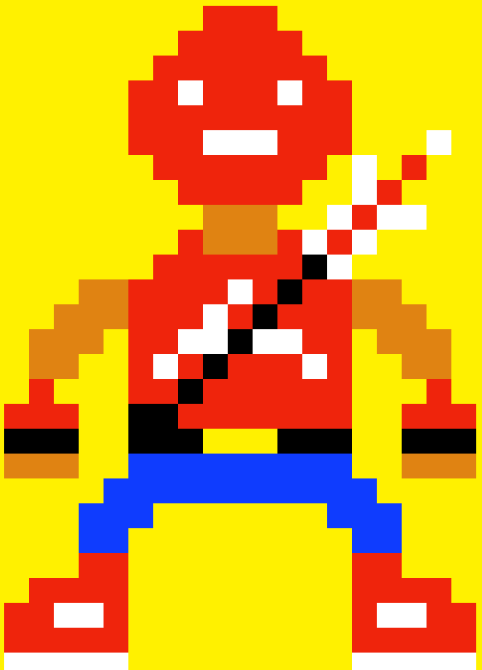

     

Character 2: Villains

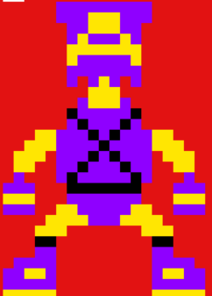

  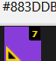

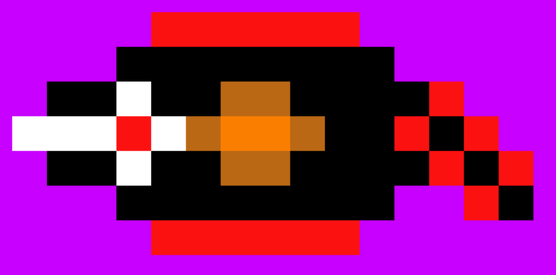

   

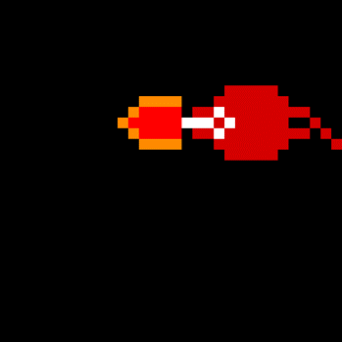

   

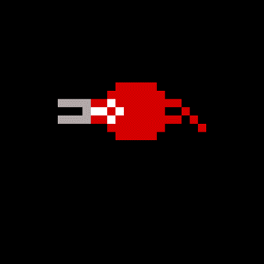

   #878AA2

Environments



  



   #878AA2



     

# 

# 

# **Fonts**

Logo

Arial Narrow: Brandis is of apparent mixed racial heritage.

In Game Text

Times New Roman: Brandis is of apparent mixed racial heritage.

# **Proportion/Scale**

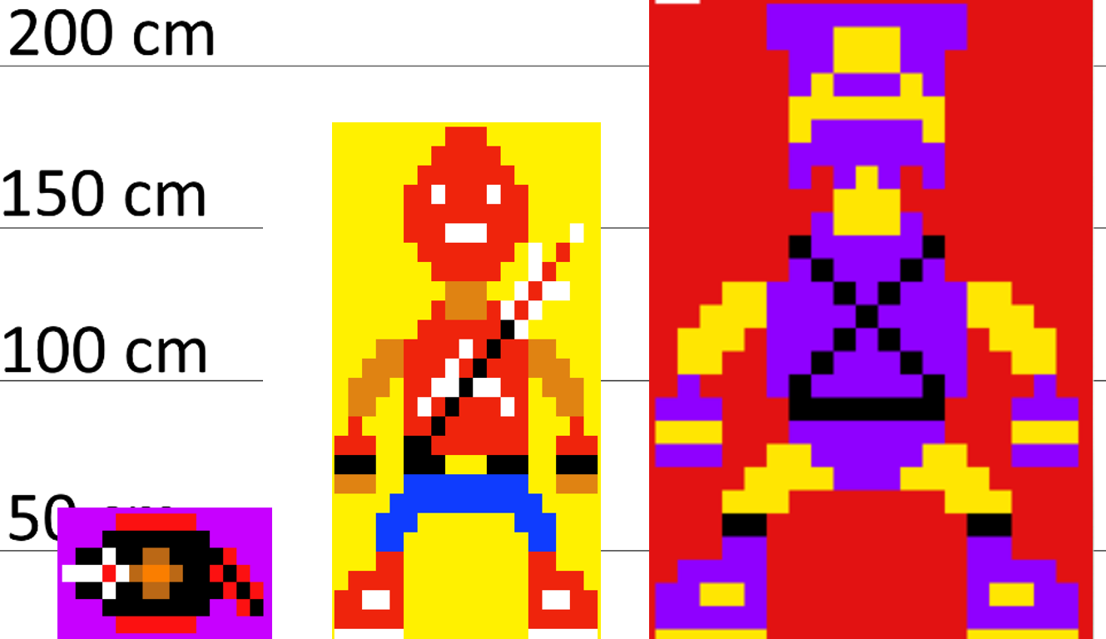

Height comparison between a Flying Bionic, Aceman and Evan Archer. Evan Archer is above six feet, while Aceman is an average height for a teenager. The Flying Bionic is slightly under two feet.

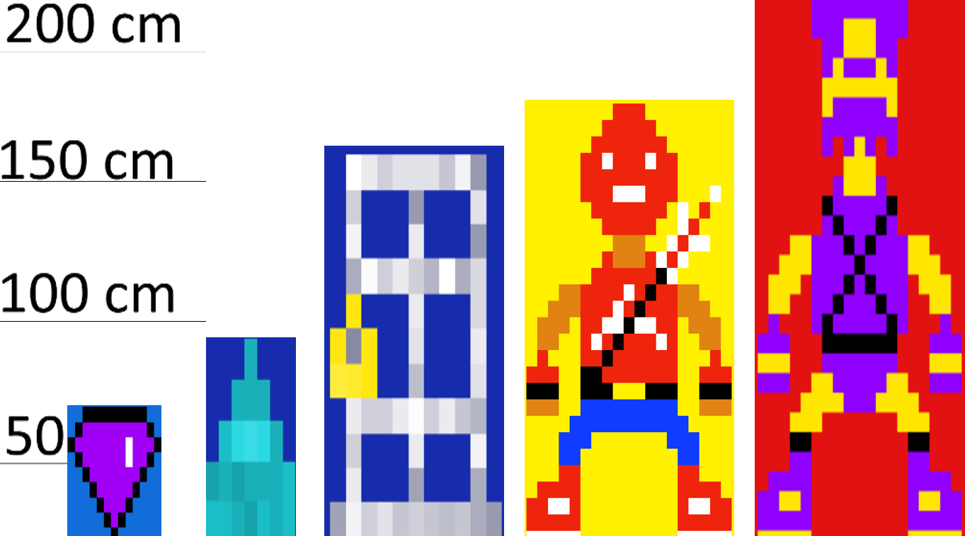

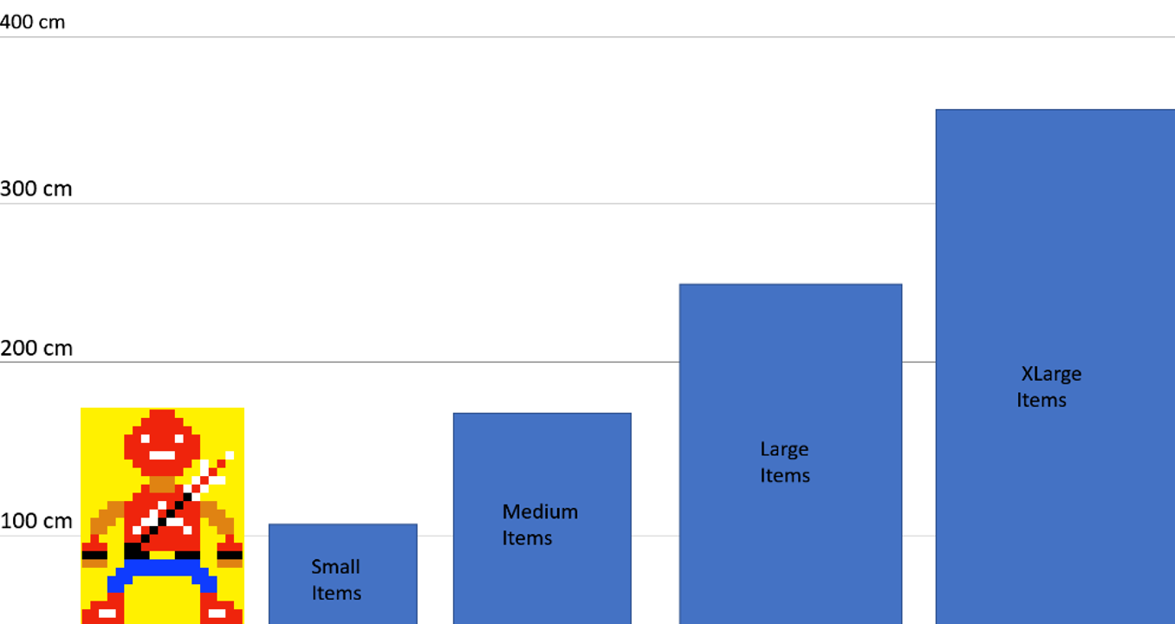

# **Asset List**

Characters

|  |  |  |
| --- | --- | --- |
| **Character Name** | **File Name** | **Approximate Size** |
| Aceman/ Johnathan Brandis | ACEJB | Medium |
| Evan Archer | EVA | Large |
| Orphans | ORP | Varies |
| Flying Bionic | FLYB | Small |
| Suicide Bionic | SUICB | Small |
| Stabbing Bionic | STBB | Small |

Environment

|  |  |  |
| --- | --- | --- |
| **Level Assets** | **File Name** | **Approximate Size** |
| Cages | CGS | Medium |
| Falling Spikes | FASPK | Varies |
| Purple Gems | PGMS | Small |
| Orange Gems | OGMS | Small |
| Pit Spikes | GRNDSPK | Large |

# **Animation List**

|  |  |  |  |
| --- | --- | --- | --- |
| **Character** | **Animation Names** | **Number of Frames** | **Description** |
| Aceman | Walking | 6 | Aceman walks back and forth in the level. |
| Aceman | Jumping | 6 | Aceman crouches and rises into the air. |
| Aceman | Attack | 5 | Aceman thrusts his sword forward. |
| Aceman | Death | 5 | Aceman falls onto the ground and cries. |
| Aceman | Victory | 5 | Aceman dances by raising his arms up and down. |
| Evan Archer | Walking | 6 | Archer Walks back in forth during the boss fight. |
| Evan Archer | Super Cannon | 6 | Archer fires a yellow beam at the player. |
| Evan Archer | Ground Cannon | 6 | Archer fires beams downward that rise back up. |
| Evan Archer | Charge | 4 | Archer charges at the player. |
| Evan Archer | Victory | 4 | Archer fires at the ground in victory. |
| Flying Bionic | Movement | 10 | The Bionic navigates back and forth in the level. |
| Flying Bionic | Attack | 5 | The Bionic fires a projectile at the player. |
| Flying Bionic | Death | 4 | The Bionic explodes into a fiery cloud. |
| Suicide Bionic | Death/Attack | 4 | The Suicide Bionic explodes upon noticing the player. |
| Stabbing Bionic | Movement/Attack | 10 | The Stabbing Bionic flies around with its sharp nose. |
| Stabbing Bionic | Death | 4 | The Stabbing Bionic explodes into a fiery cloud. |

# **Concept Art / Sketches**

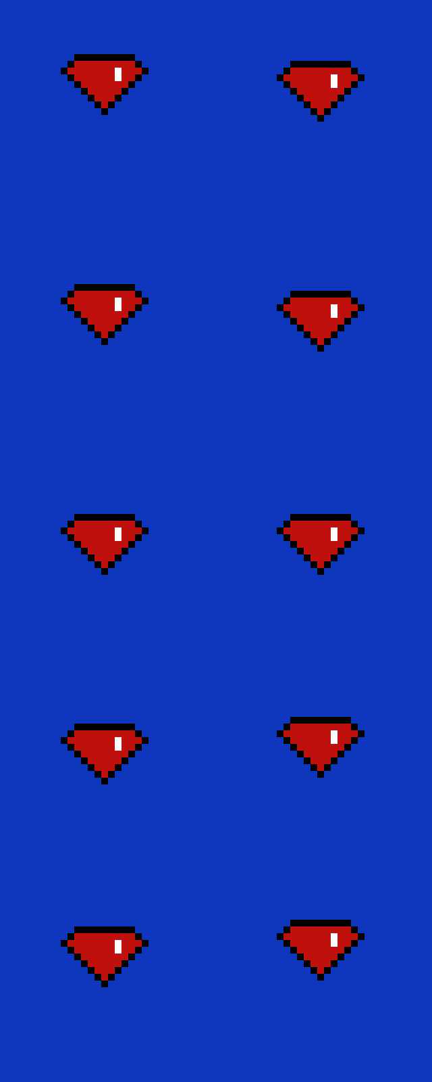

Originally, I had the gem colors as red. I changed it to purple for the final game.

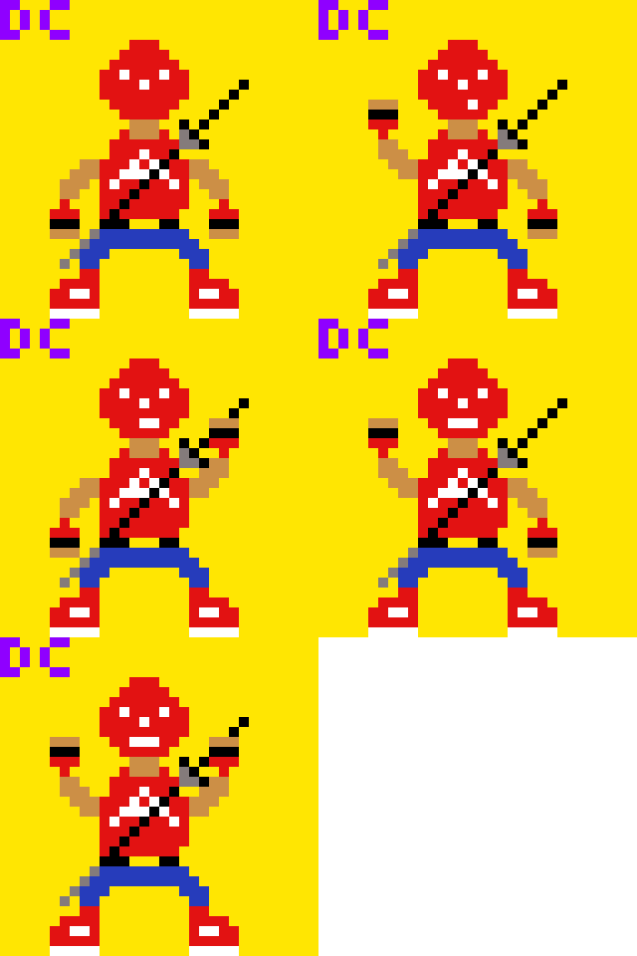

Originally, Aceman’s Sword was black with a slim design to it. I later changed it to match his red and white color scheme.

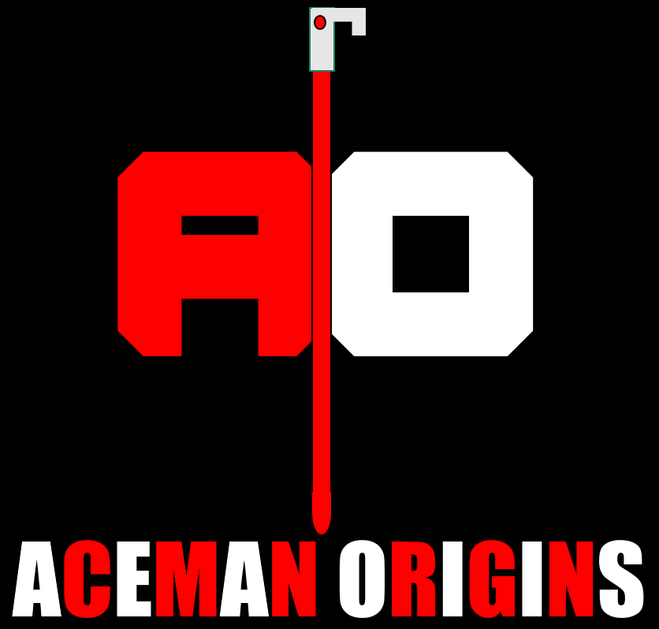

This was the earlier logo design from the first art style guide. I would later change the font to match up with the pixelated style.

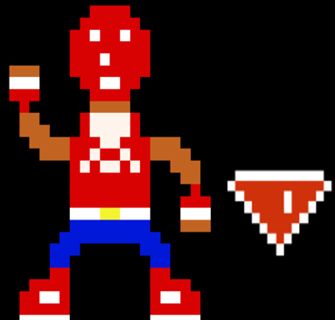

This photo from the promotional poster features a slightly different look for Aceman and the gems. In this photo, Aceman has darker skin, a wider neck and a different design for his shirt’s A. The gem has a color scheme that is no longer planned for the game.

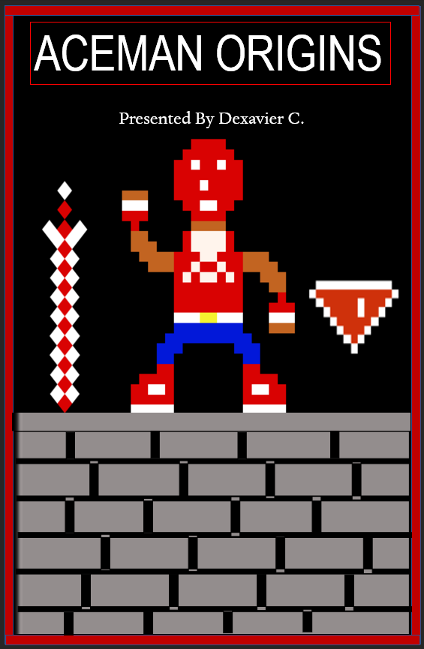 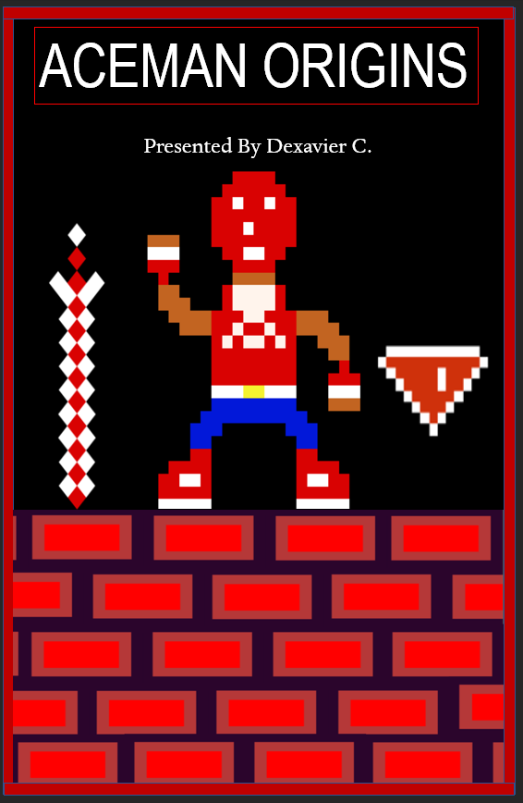

The one on the left is the original poster with the grey brick textures. I changed the color and appearance to better suit the game’s pixel look.

As pictured in the Villain Color Palettes Section, I had to switch all the Bionics colors to red so that it wouldn’t blend in with my final assignment’s background.